Project Objectives

A Gesture-based Tool for Sterile Browsing of Radiology Images

1.Know fundamental concepts and techniques of Convolutional Neural Network.

To build a well trained model is designed and developed using CNN.

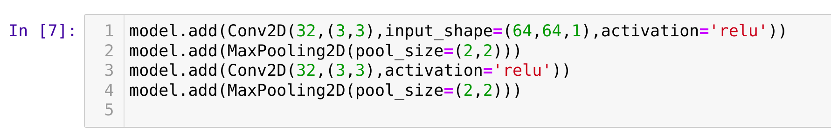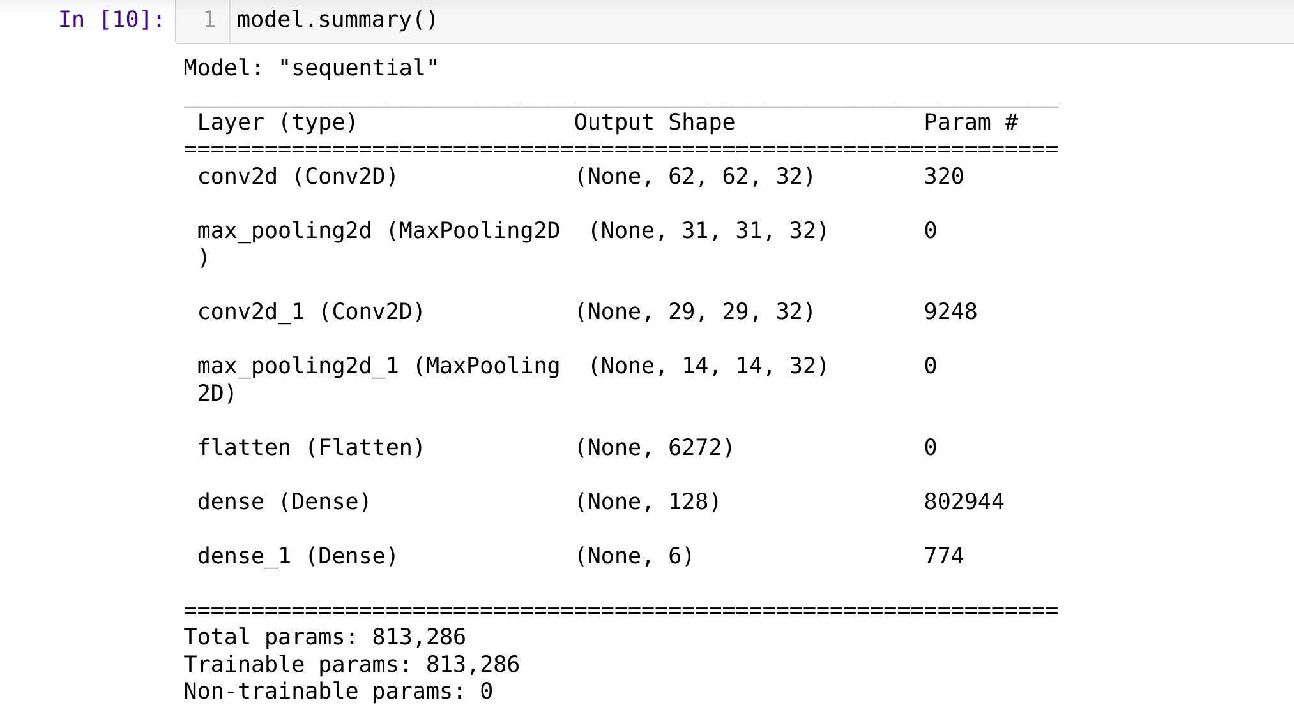

2.Gain a broad understanding of image data.

To get knowledge about how training and test images should be classified based on the model we are working.

3.Know how to pre-process/clean the data using different data preprocessing techniques.

To get an idea about rescaling, rotating cropping images can be a very good data for our model to understand , and find patterns that help to relate features of the dataset.

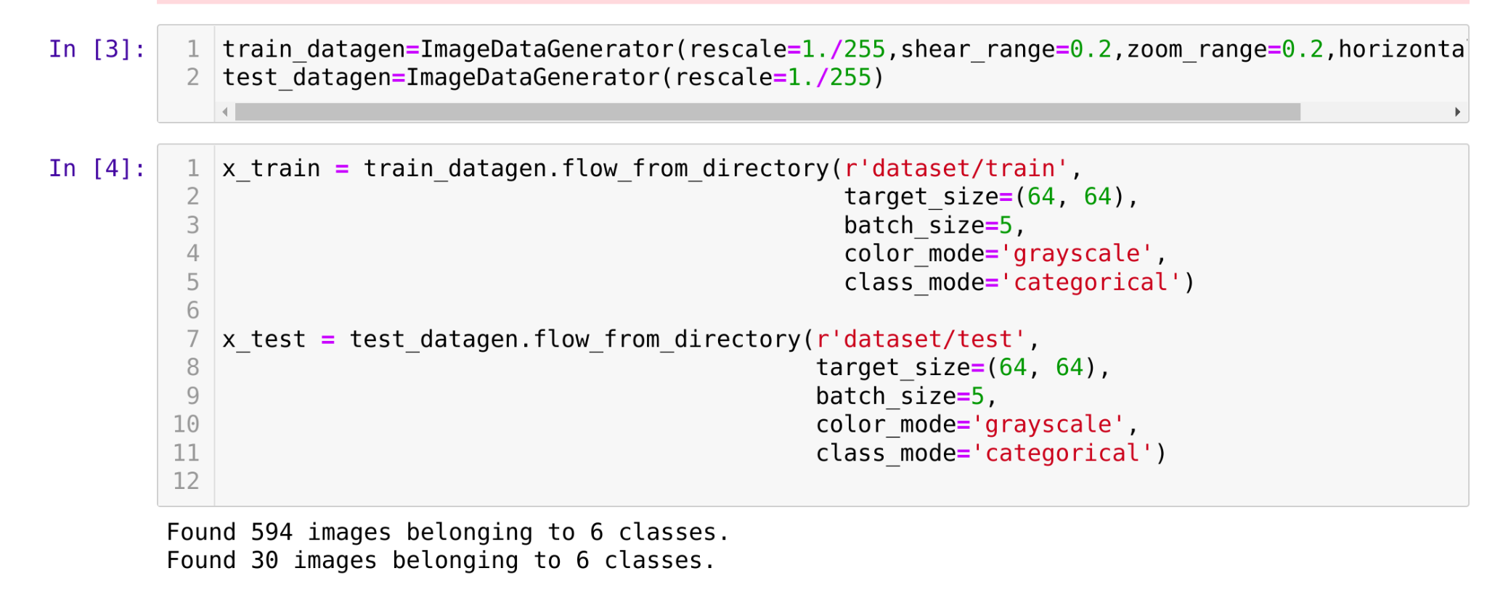

4.Know how to build a web application using the Flask framework.

Building front-end pages and calling those from our flask application . Flask is a web-framework in python which is used for building web-application